Michael Rozen

Artwork: (In no particular Order)

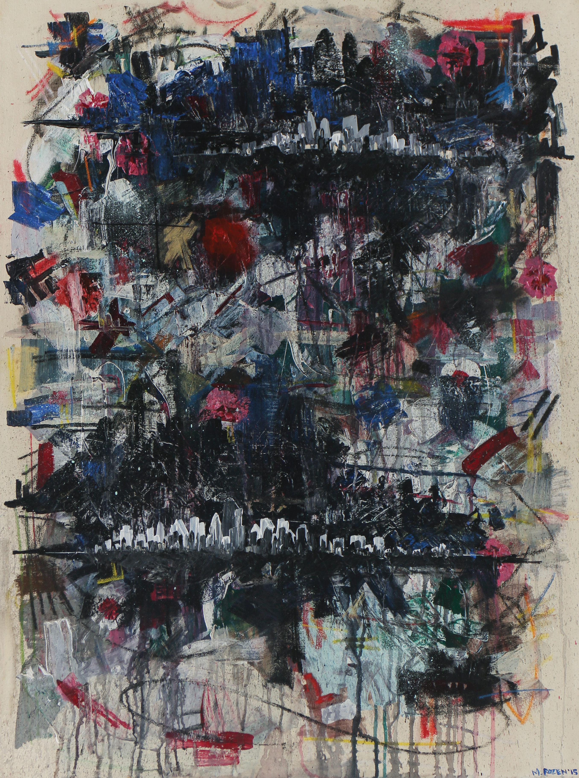

“Untitled”, 30x40”, acrylic, latex, and pastel on canvas, 2015.

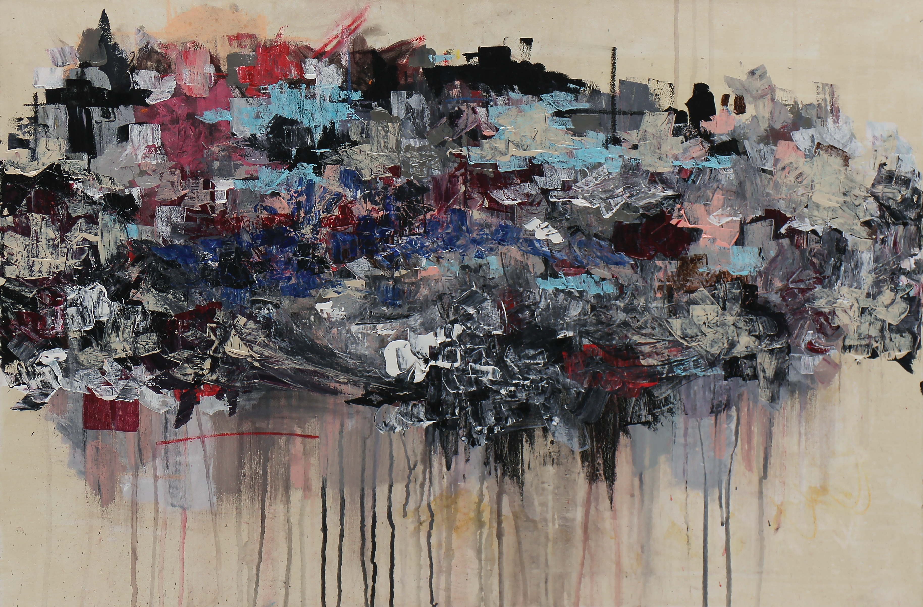

“Favela”, 24x36”, acrylic, latex, and pastel on canvas, 2015

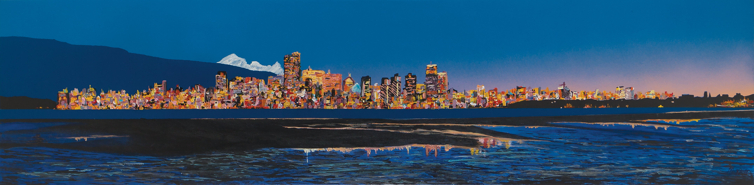

“Spanish Banks”, 18x 72”, acrylic on canvas, 2014.

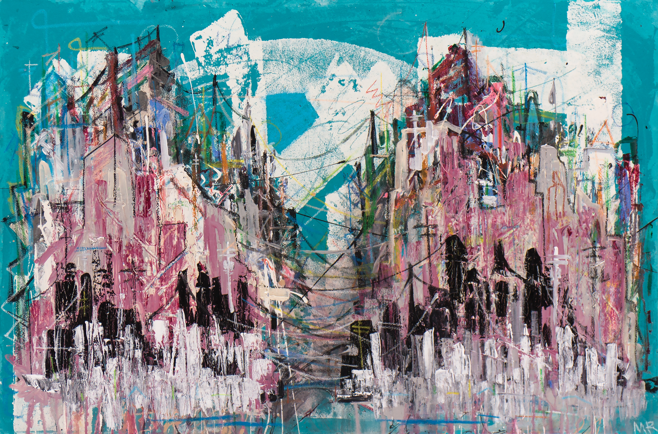

“The Boroughs”, 24x36”, acrylic, latex, and pastel on canvas, 2015.

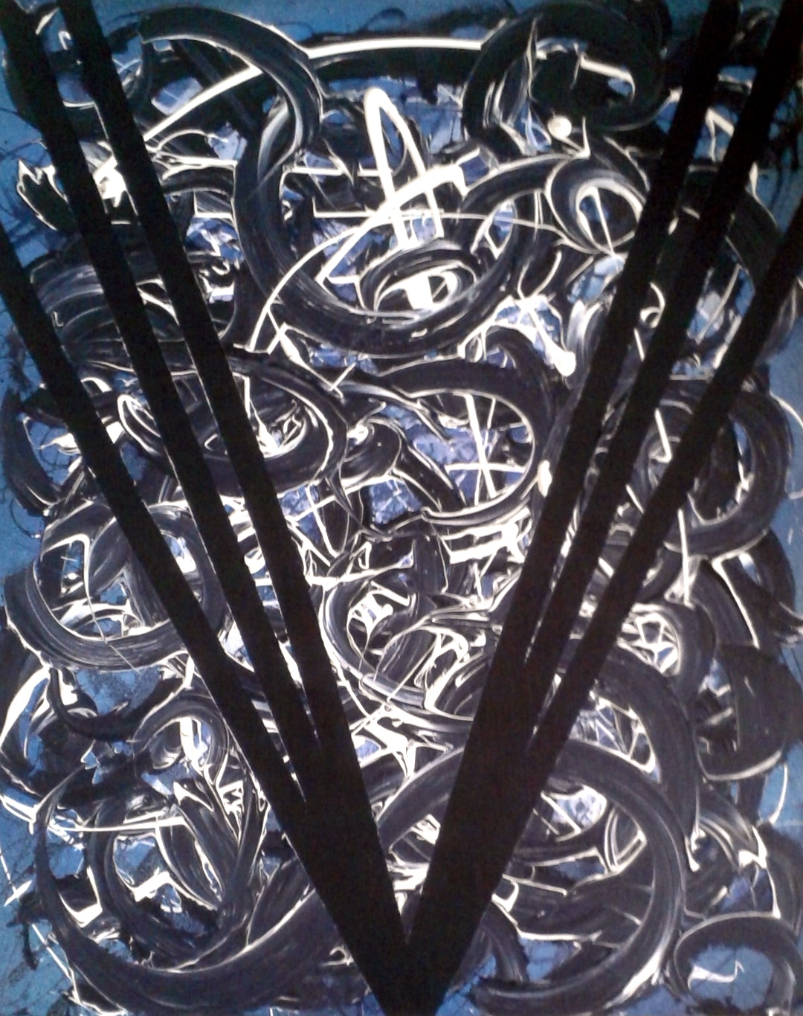

“Vancouver”, 24x36”, acrylic and latex on canvas, 2014.

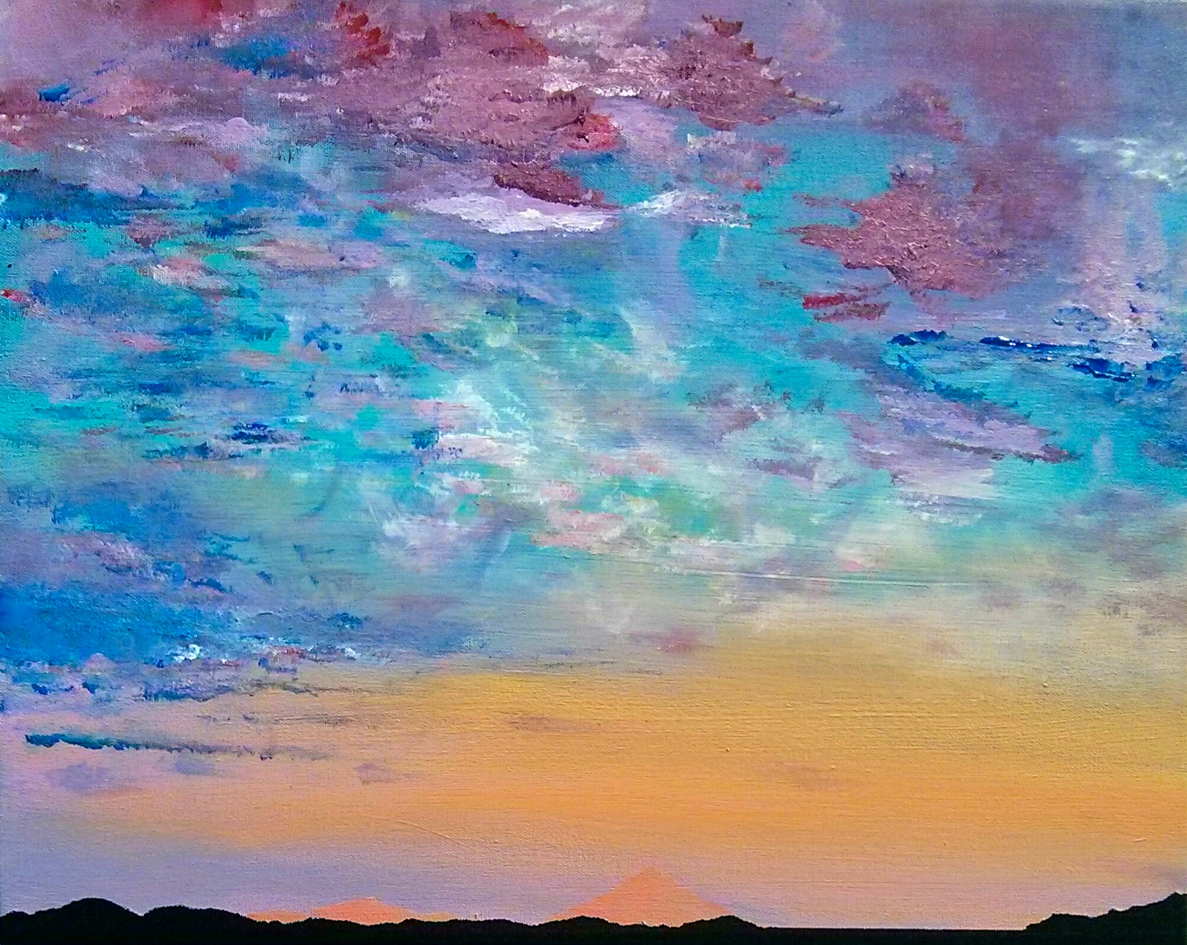

“Ephemeral Sky”, 18x24”, acrylic on canvas, 2014.

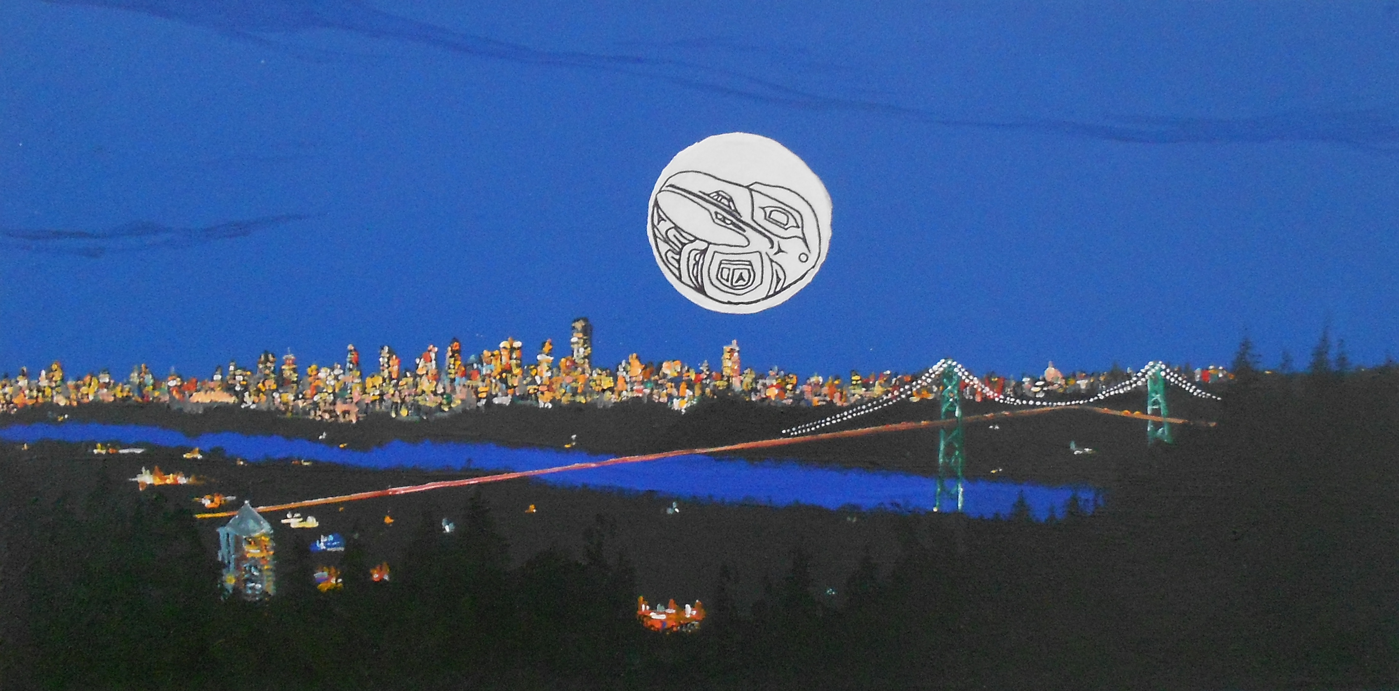

“Capilano”, 18x30, acrylic on canvas, 2015.

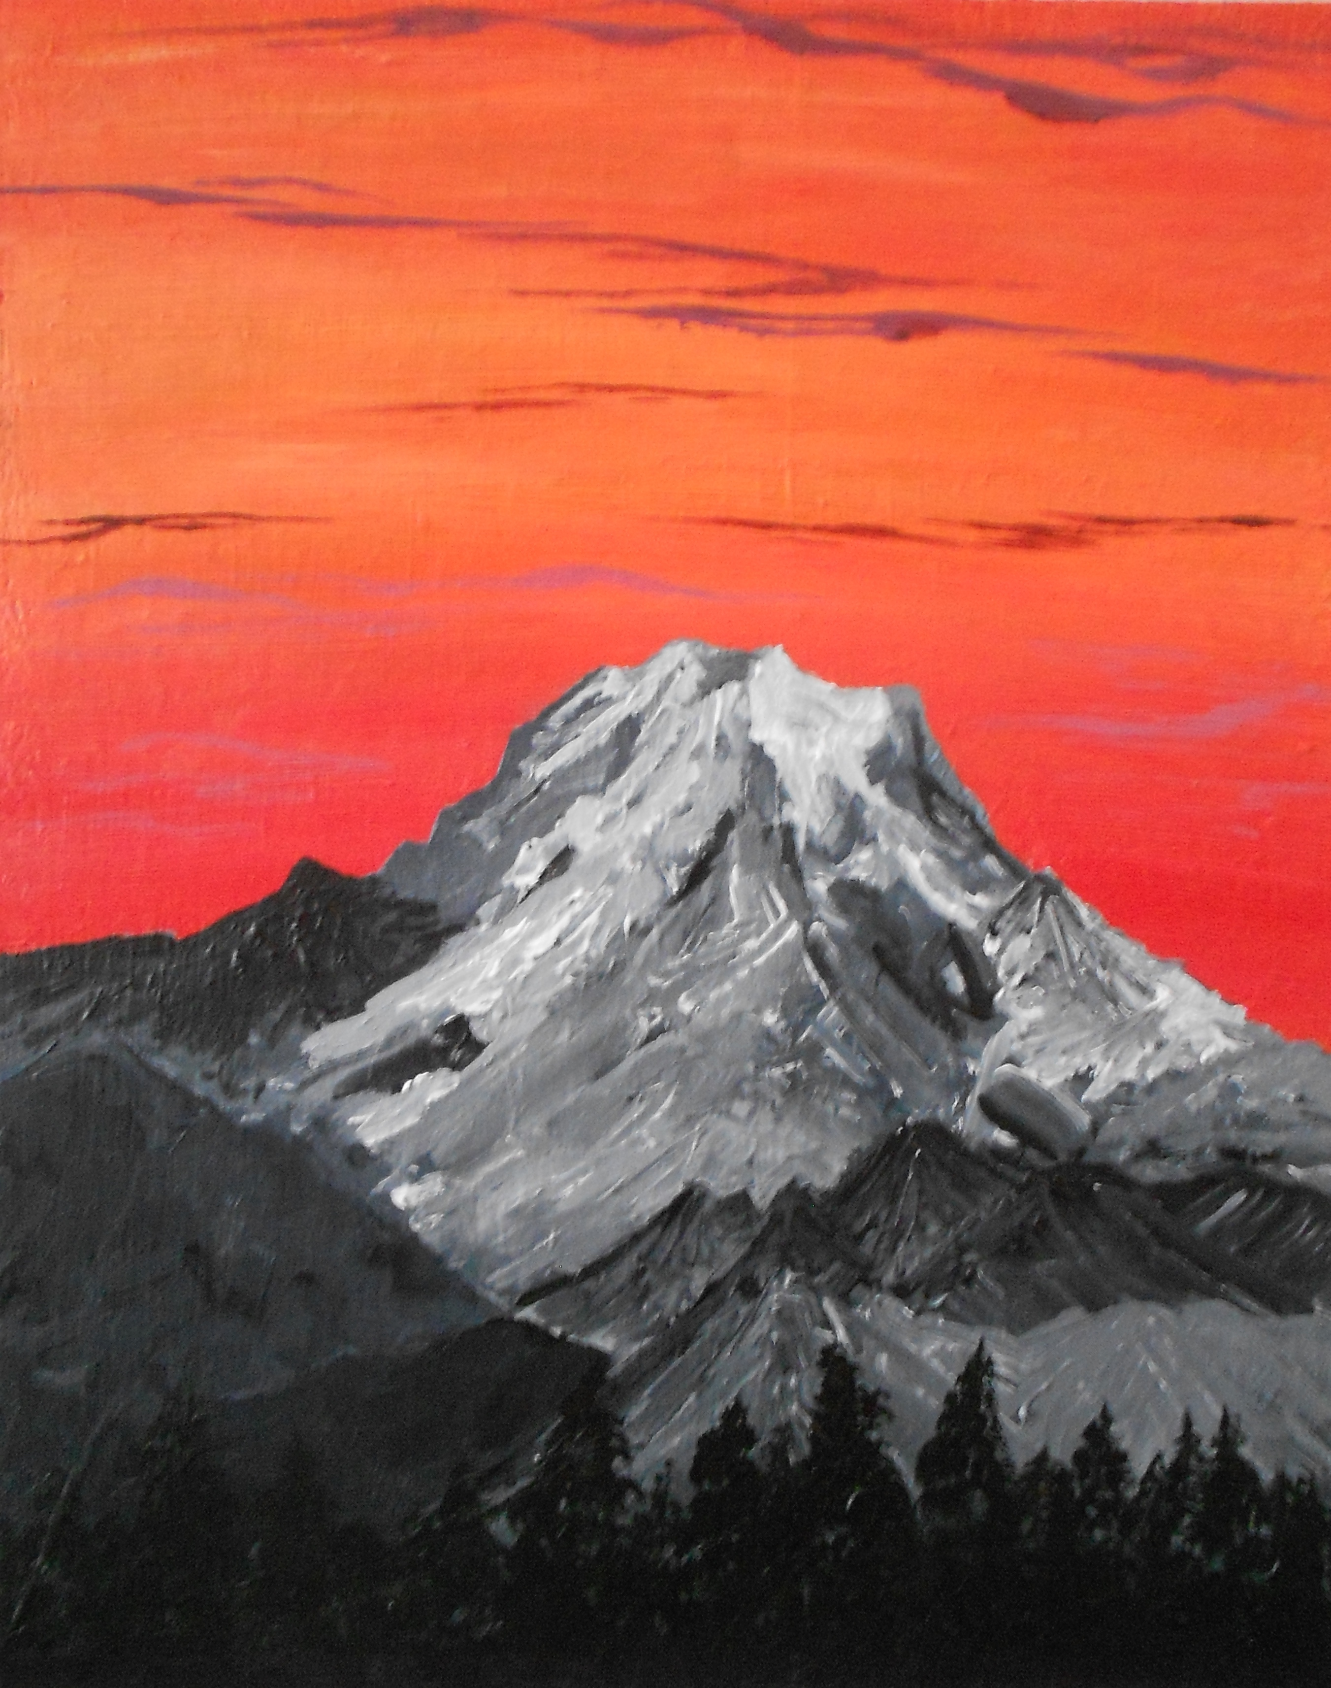

“Cascadia”, 24x36”, acrylic on canvas, 2015.

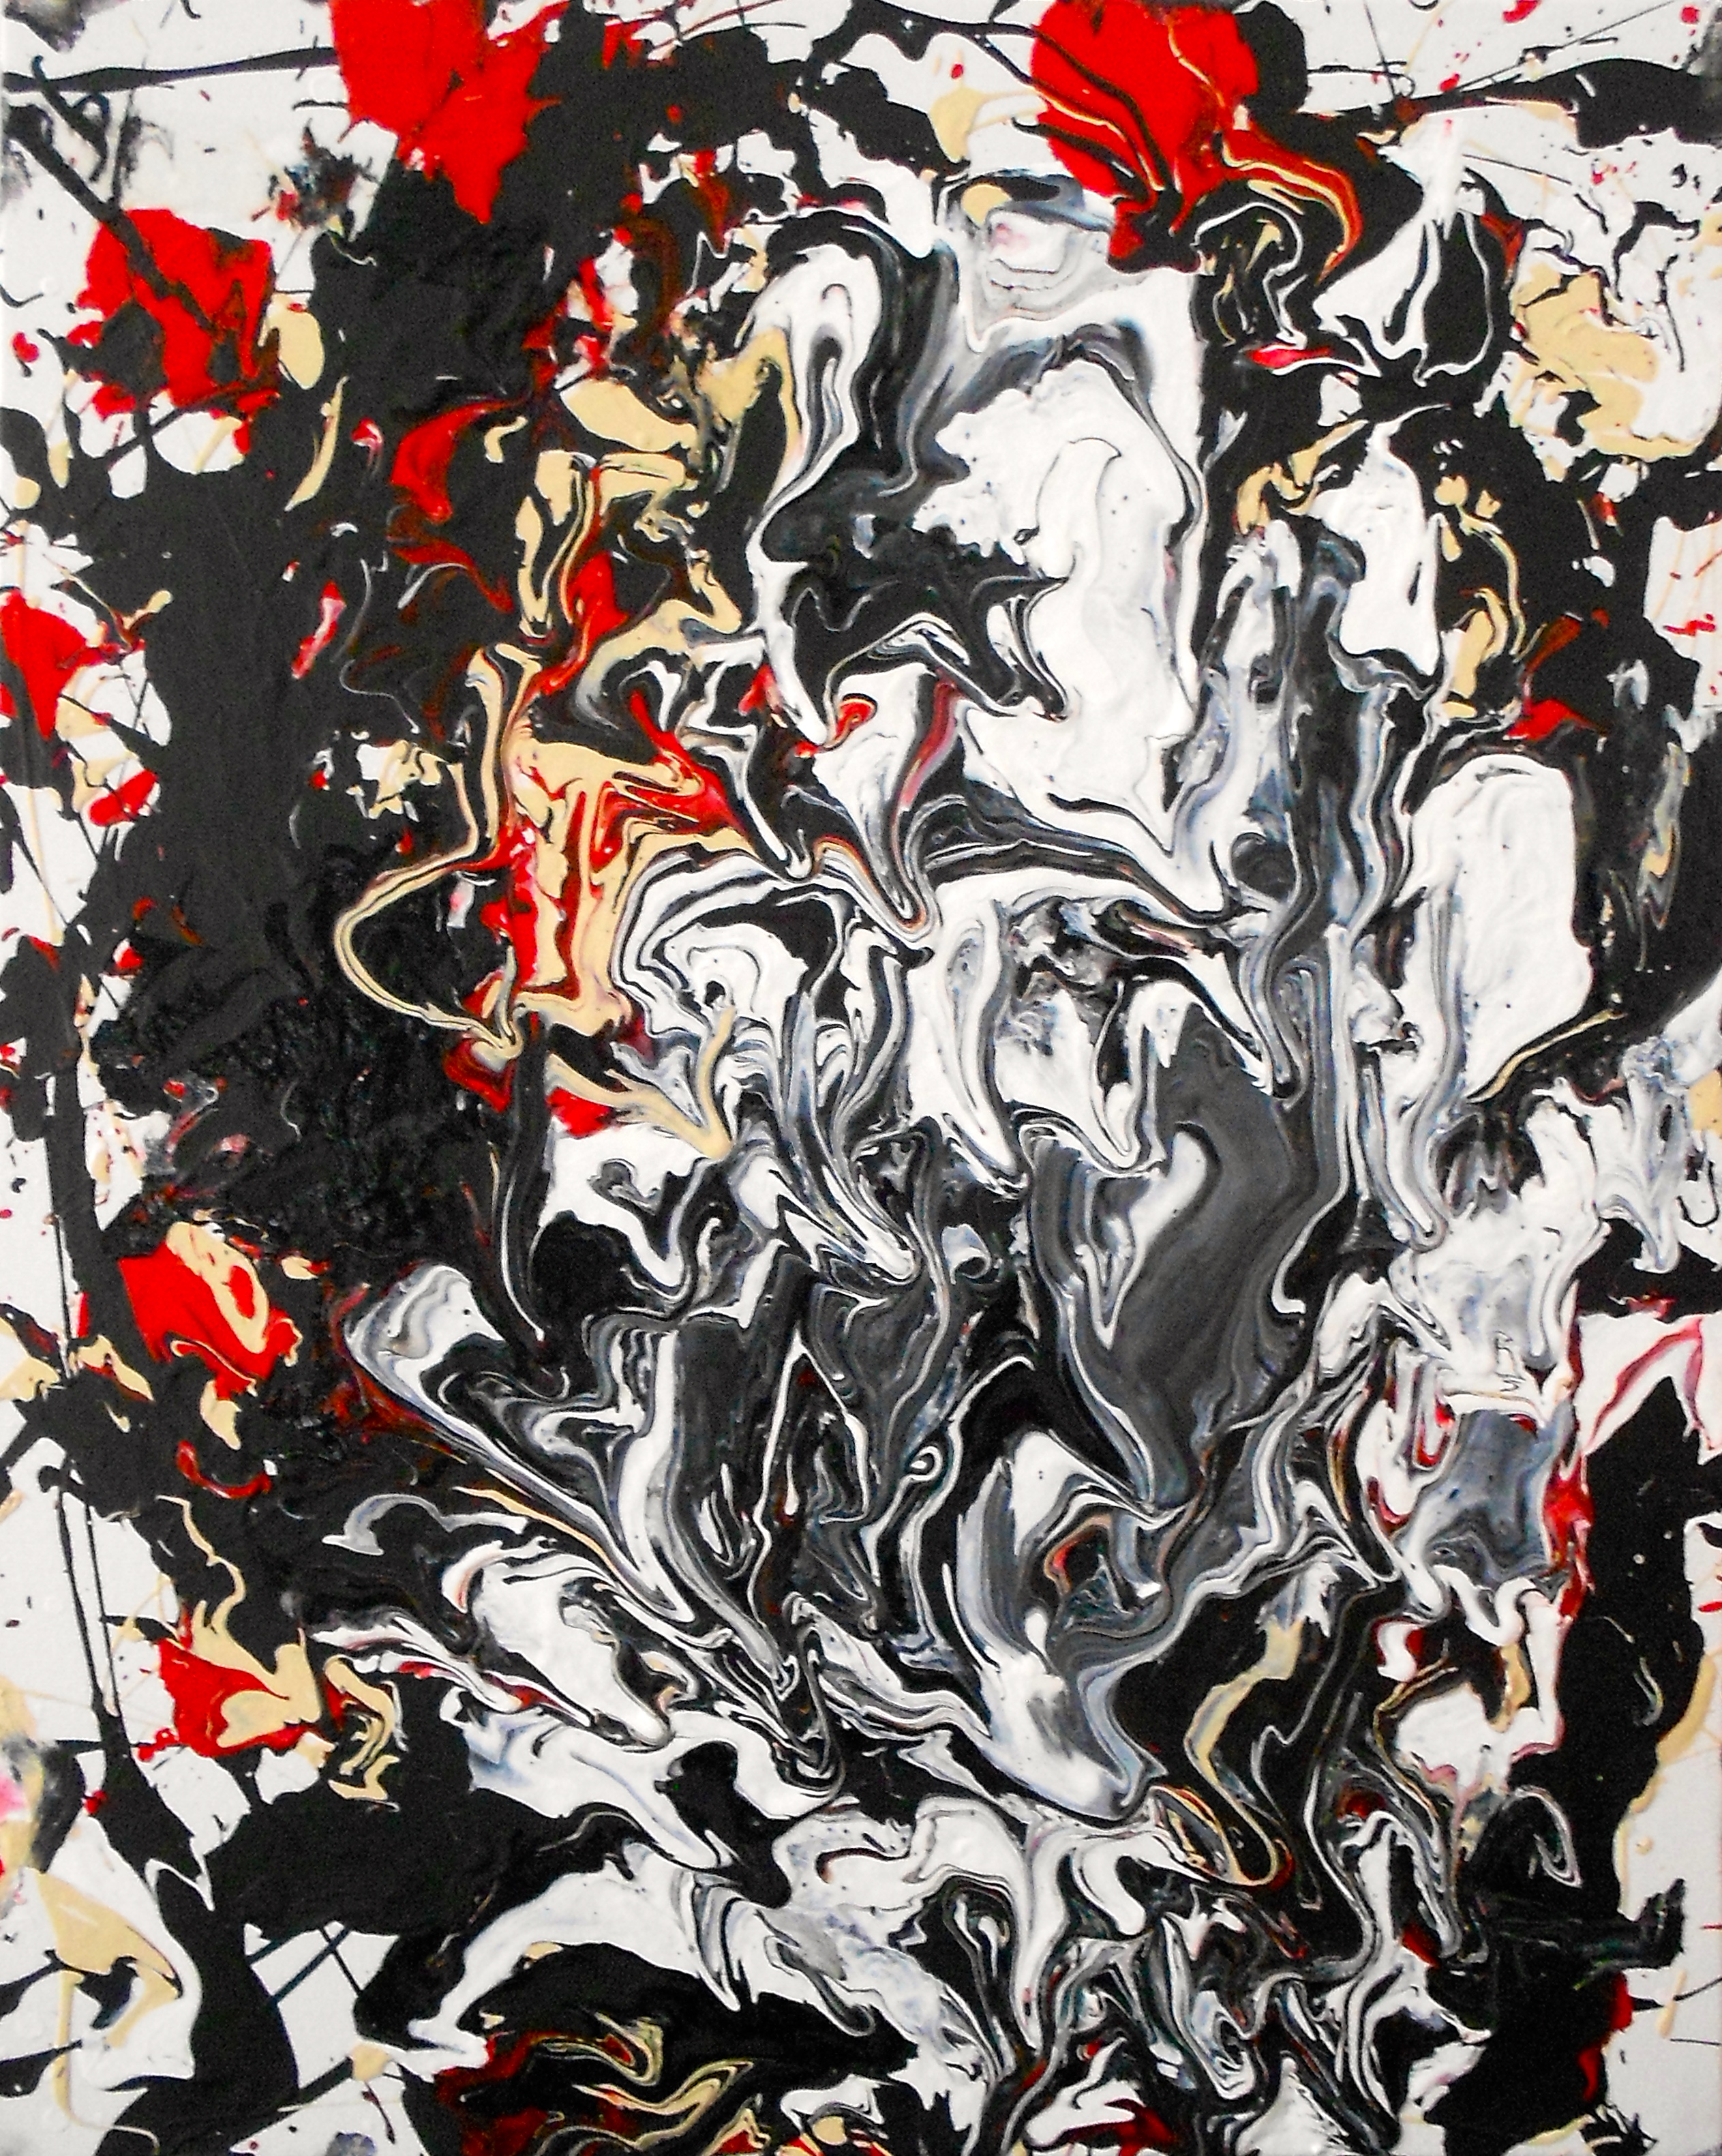

“Unconscious”, 18x24”, acrylic and latex on canvas, 2014.

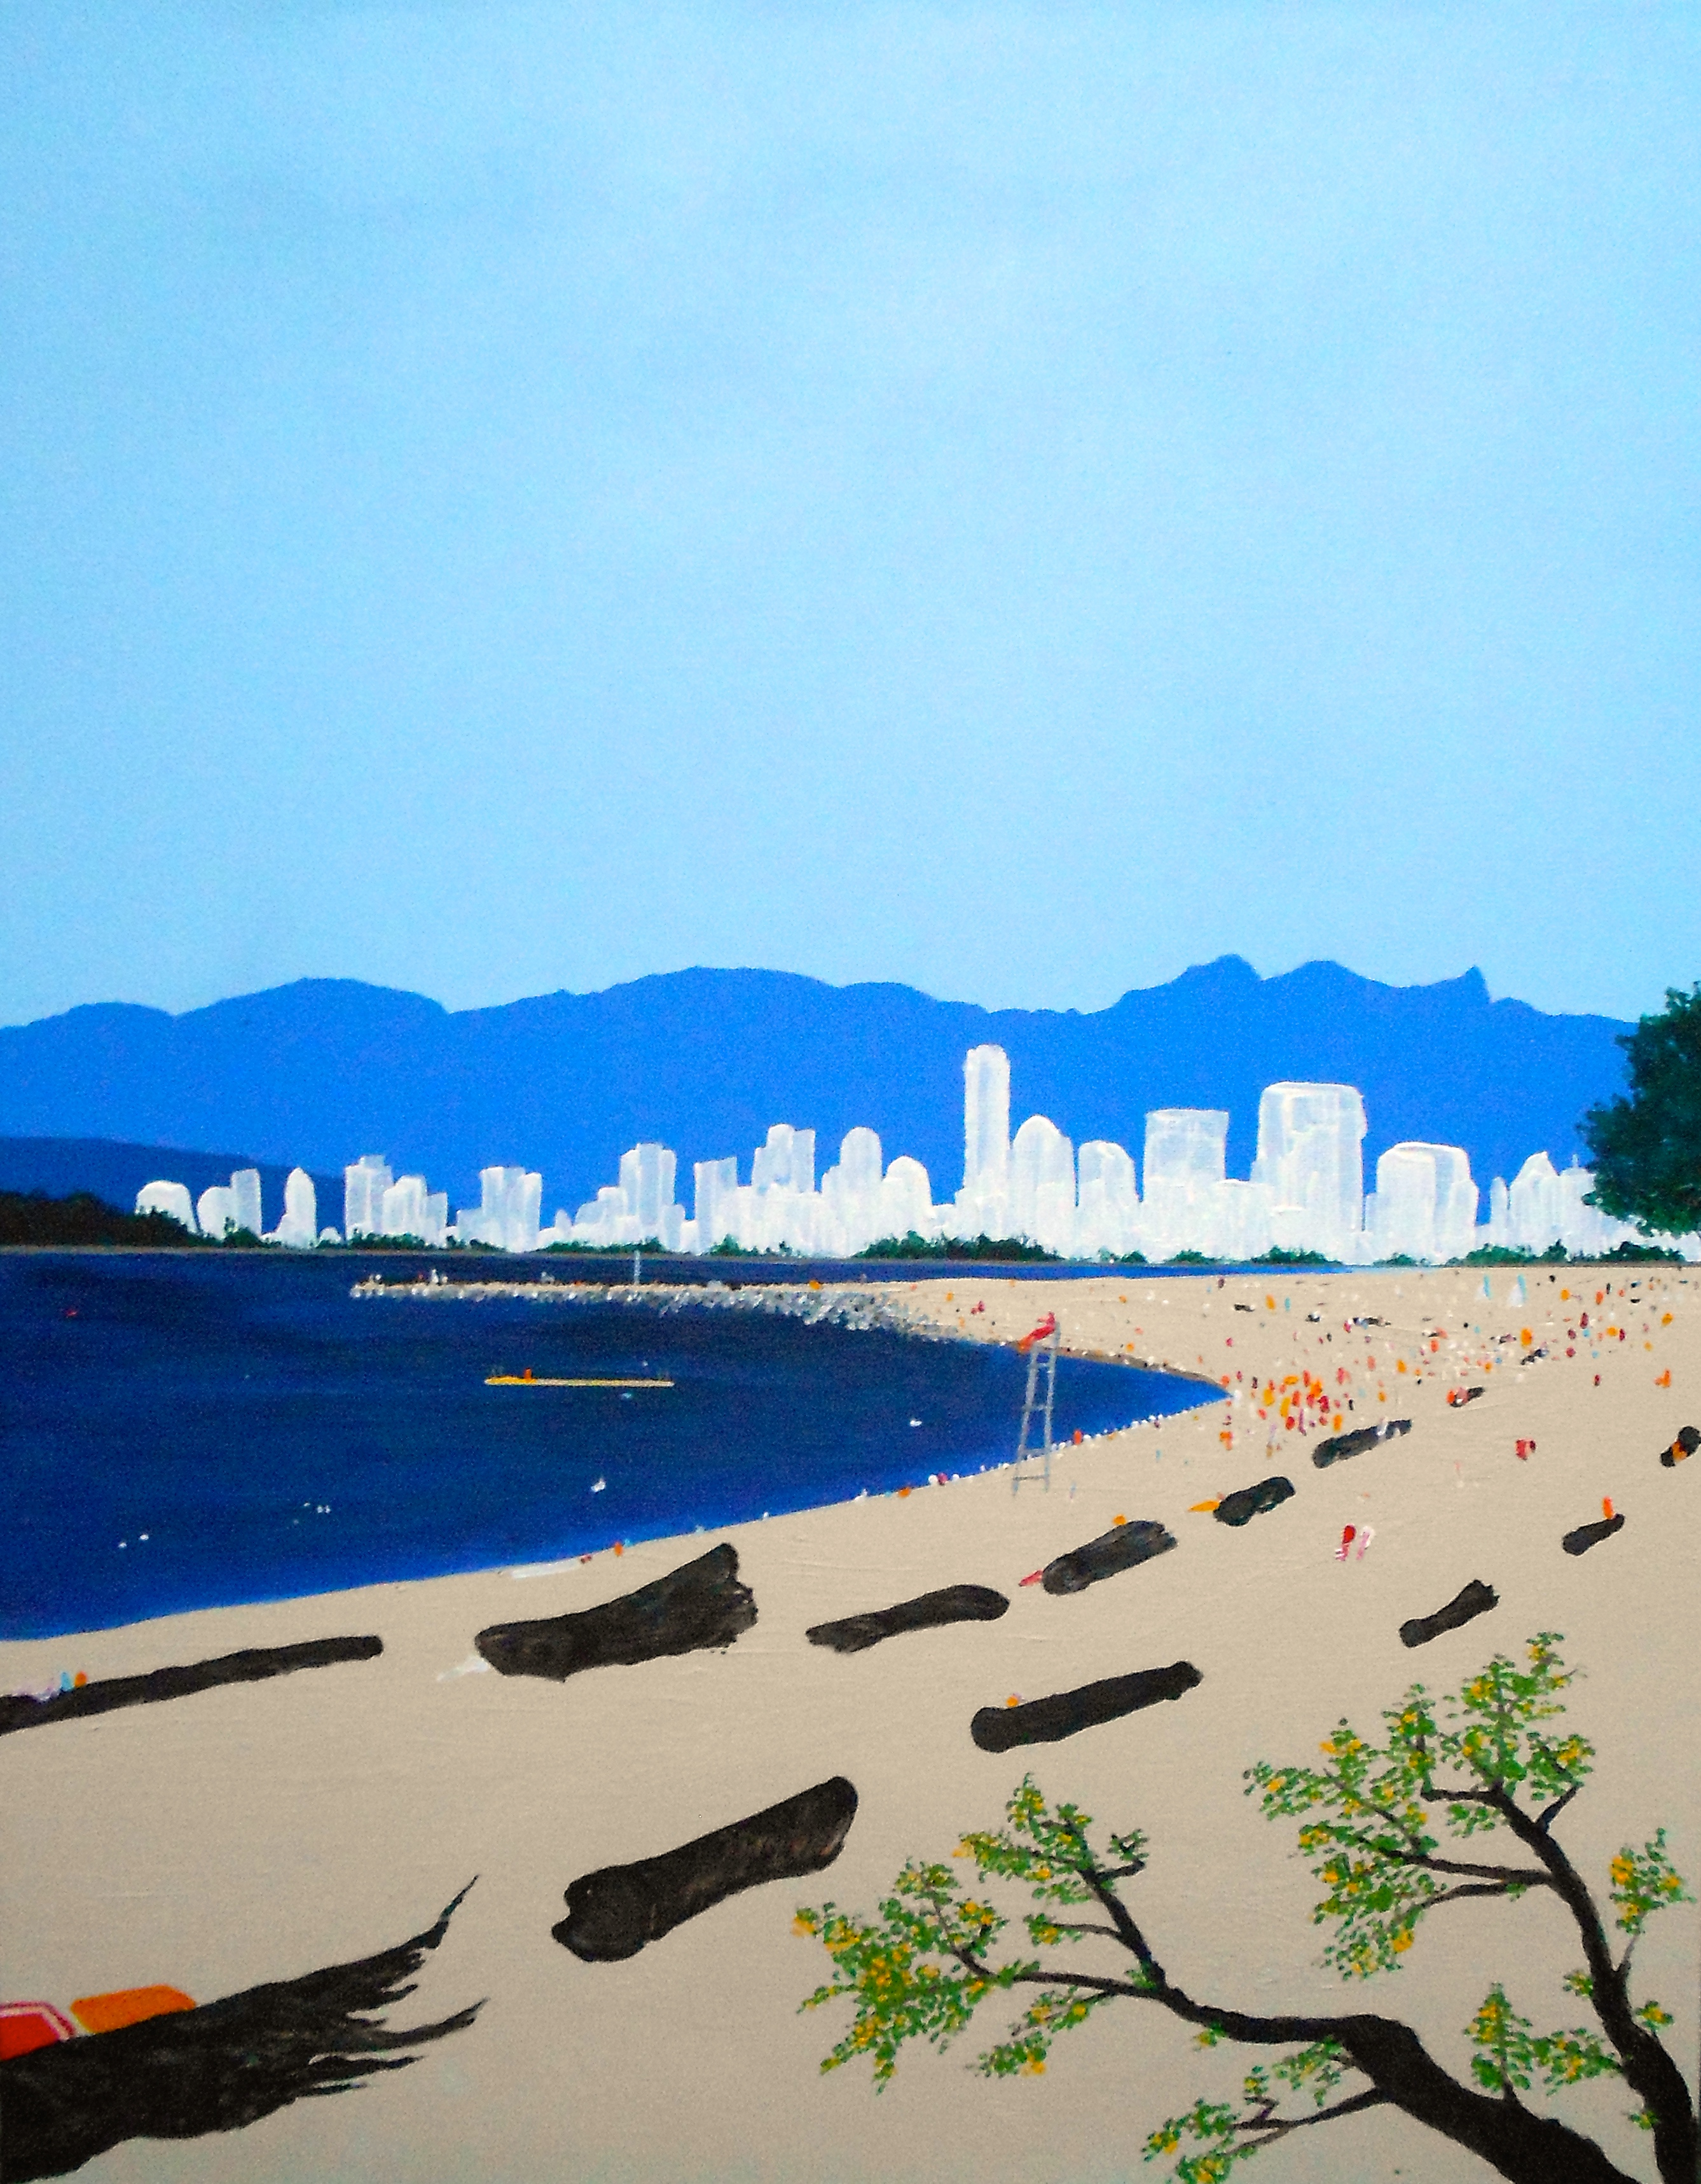

“Kitsilano”, 20x28”, acrylic on canvas, 2015.

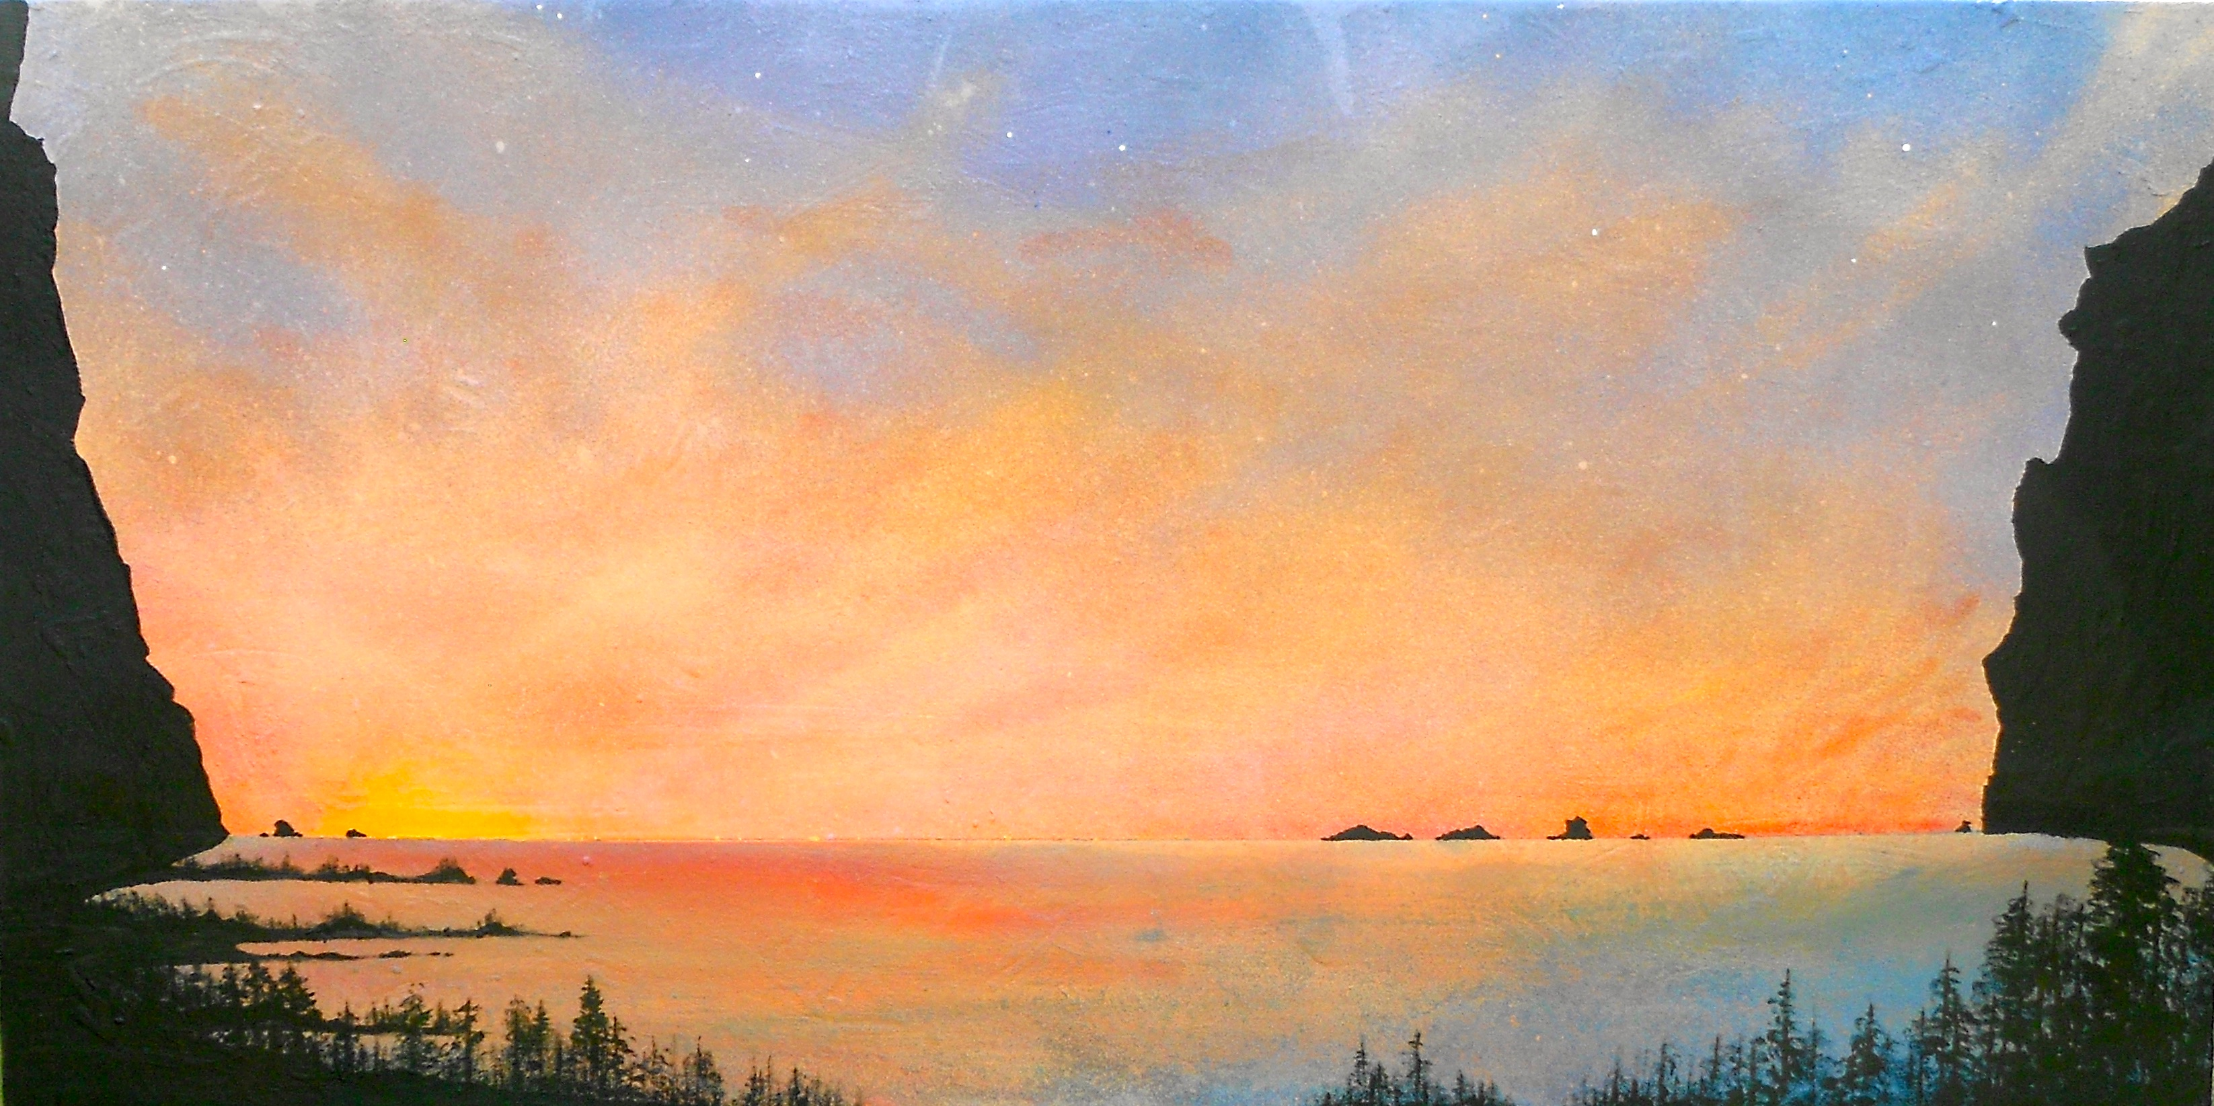

“Daybreak”, 18x30”, acrylic and latex on canvas, 2015.

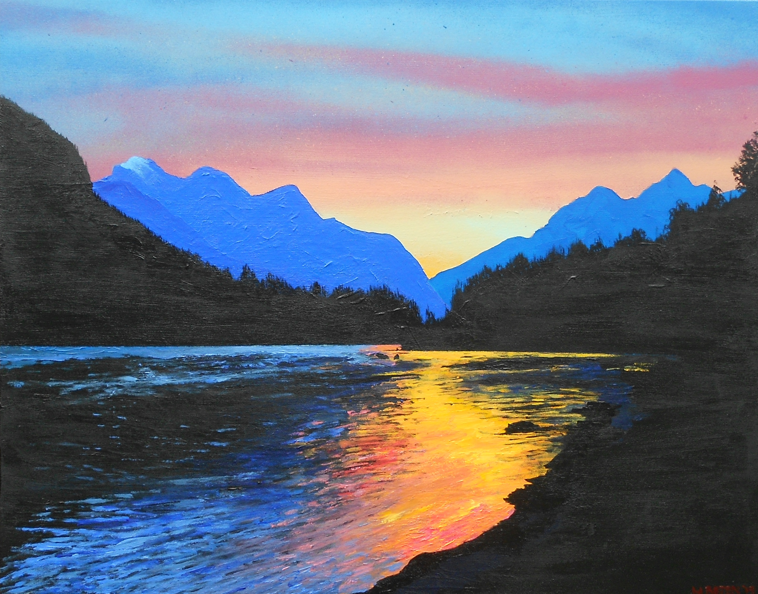

“Reflection”, 20x28”, acrylic on canvas, 2015.

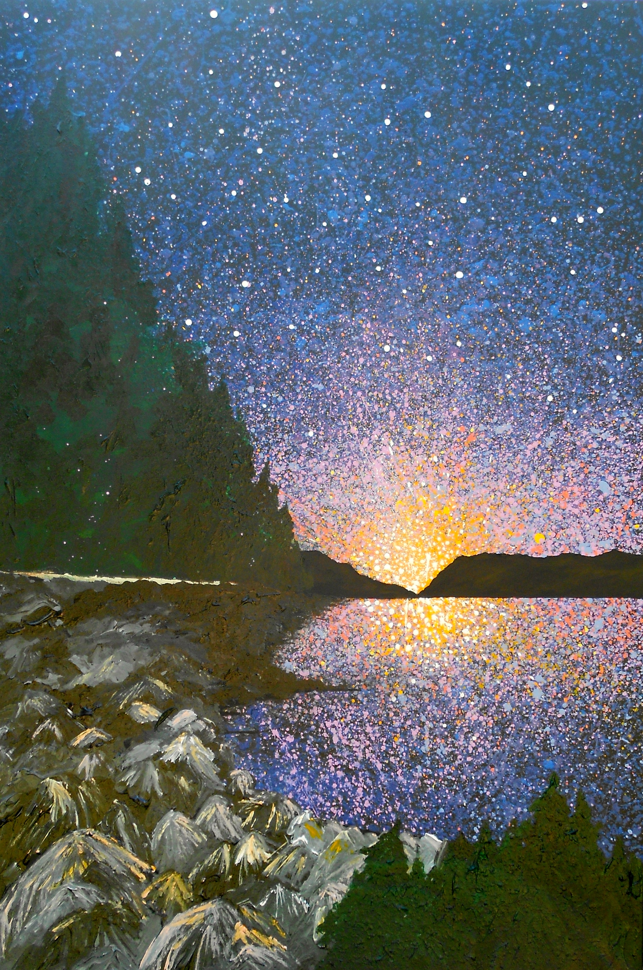

“Northwest Coast”, 24x36”, acrylic and latex on canvas, 2013.

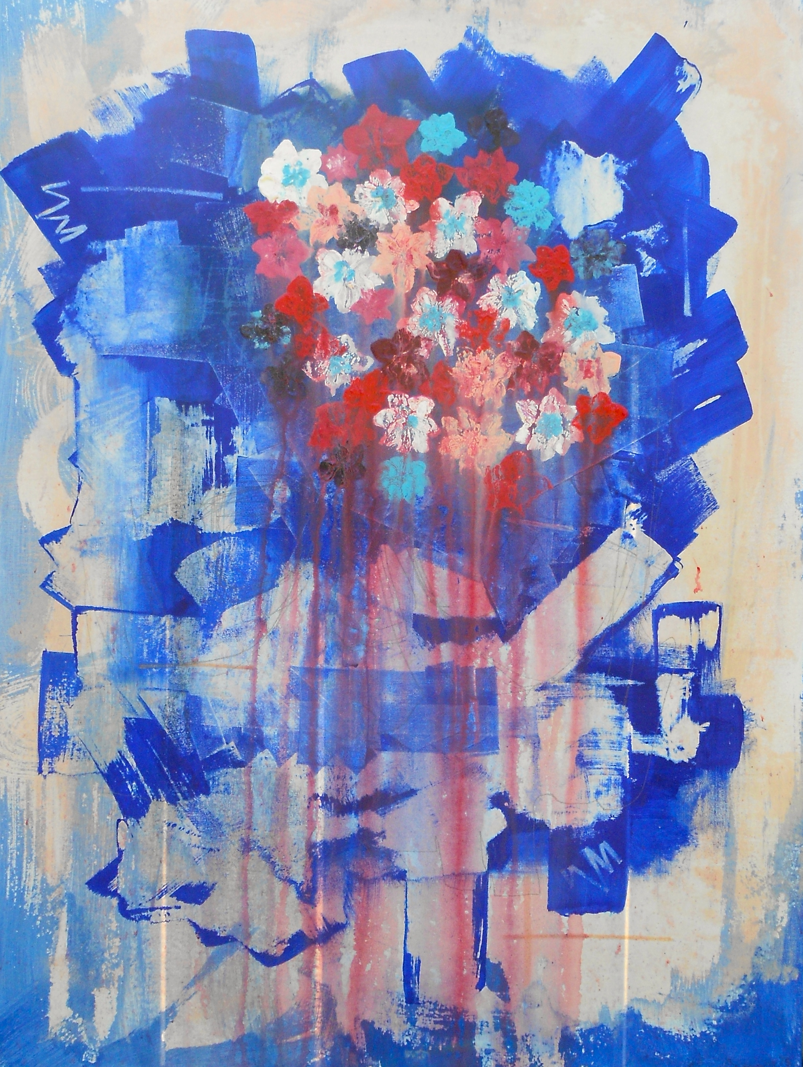

“Bleed”, 20x30”, acrylic and latex on canvas, 2015.

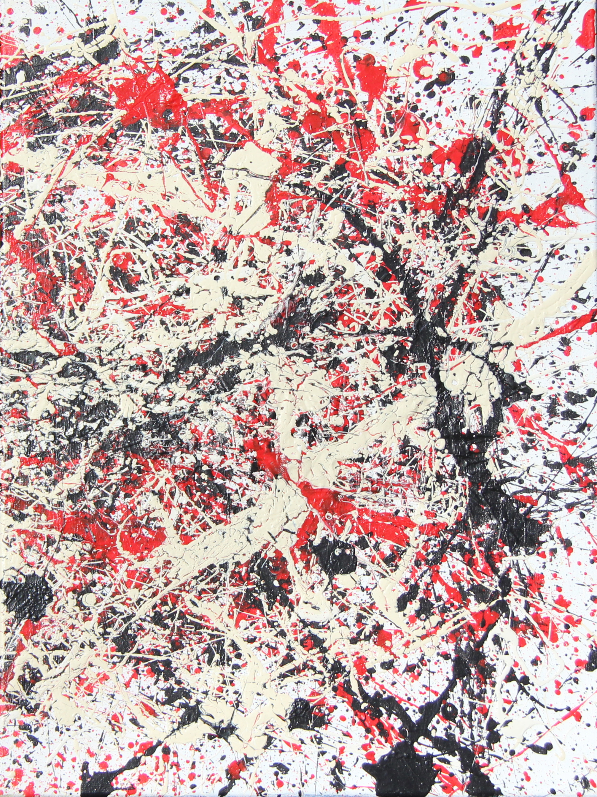

“Genesis Part 1”, acrylic and latex on canvas, 2012.

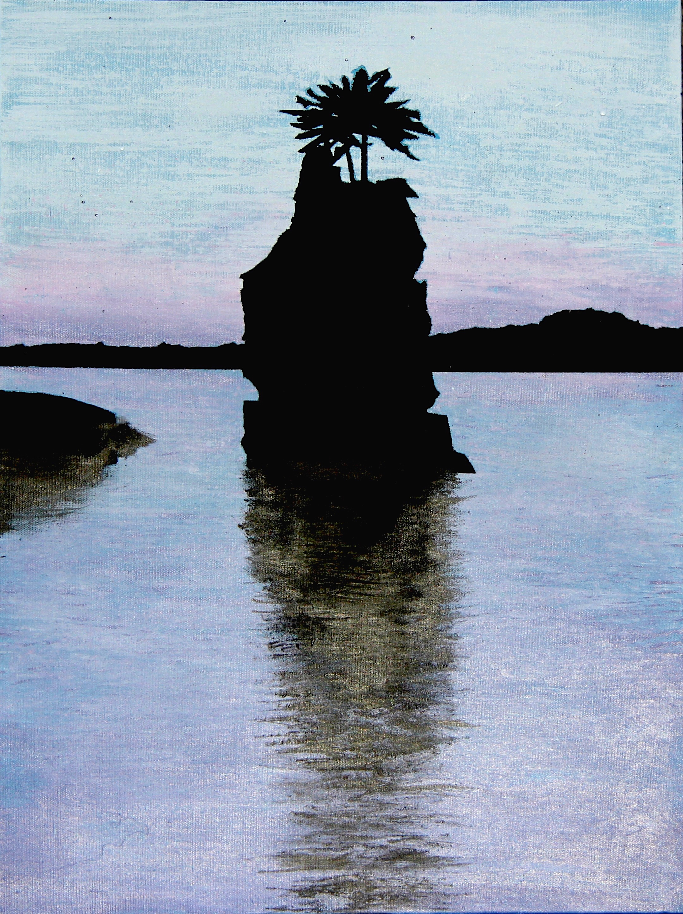

“Siwash Rock”, 18x24”, acrylic and latex on canvas, 2013.

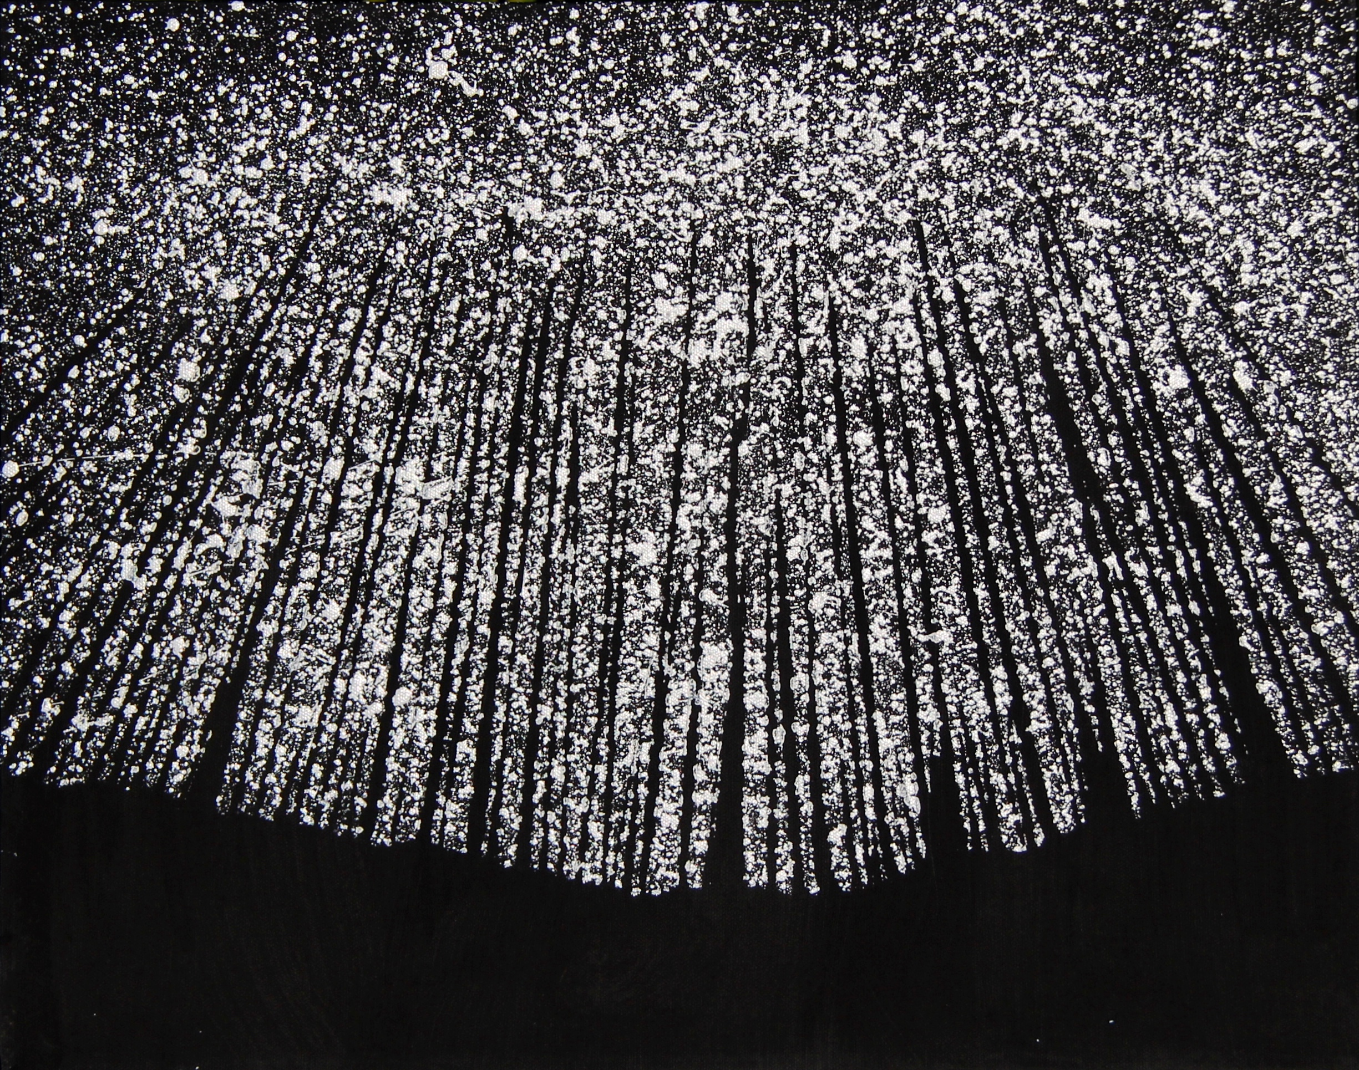

“And darkness falls”, 18x24”, acrylic on canvas, 2013.

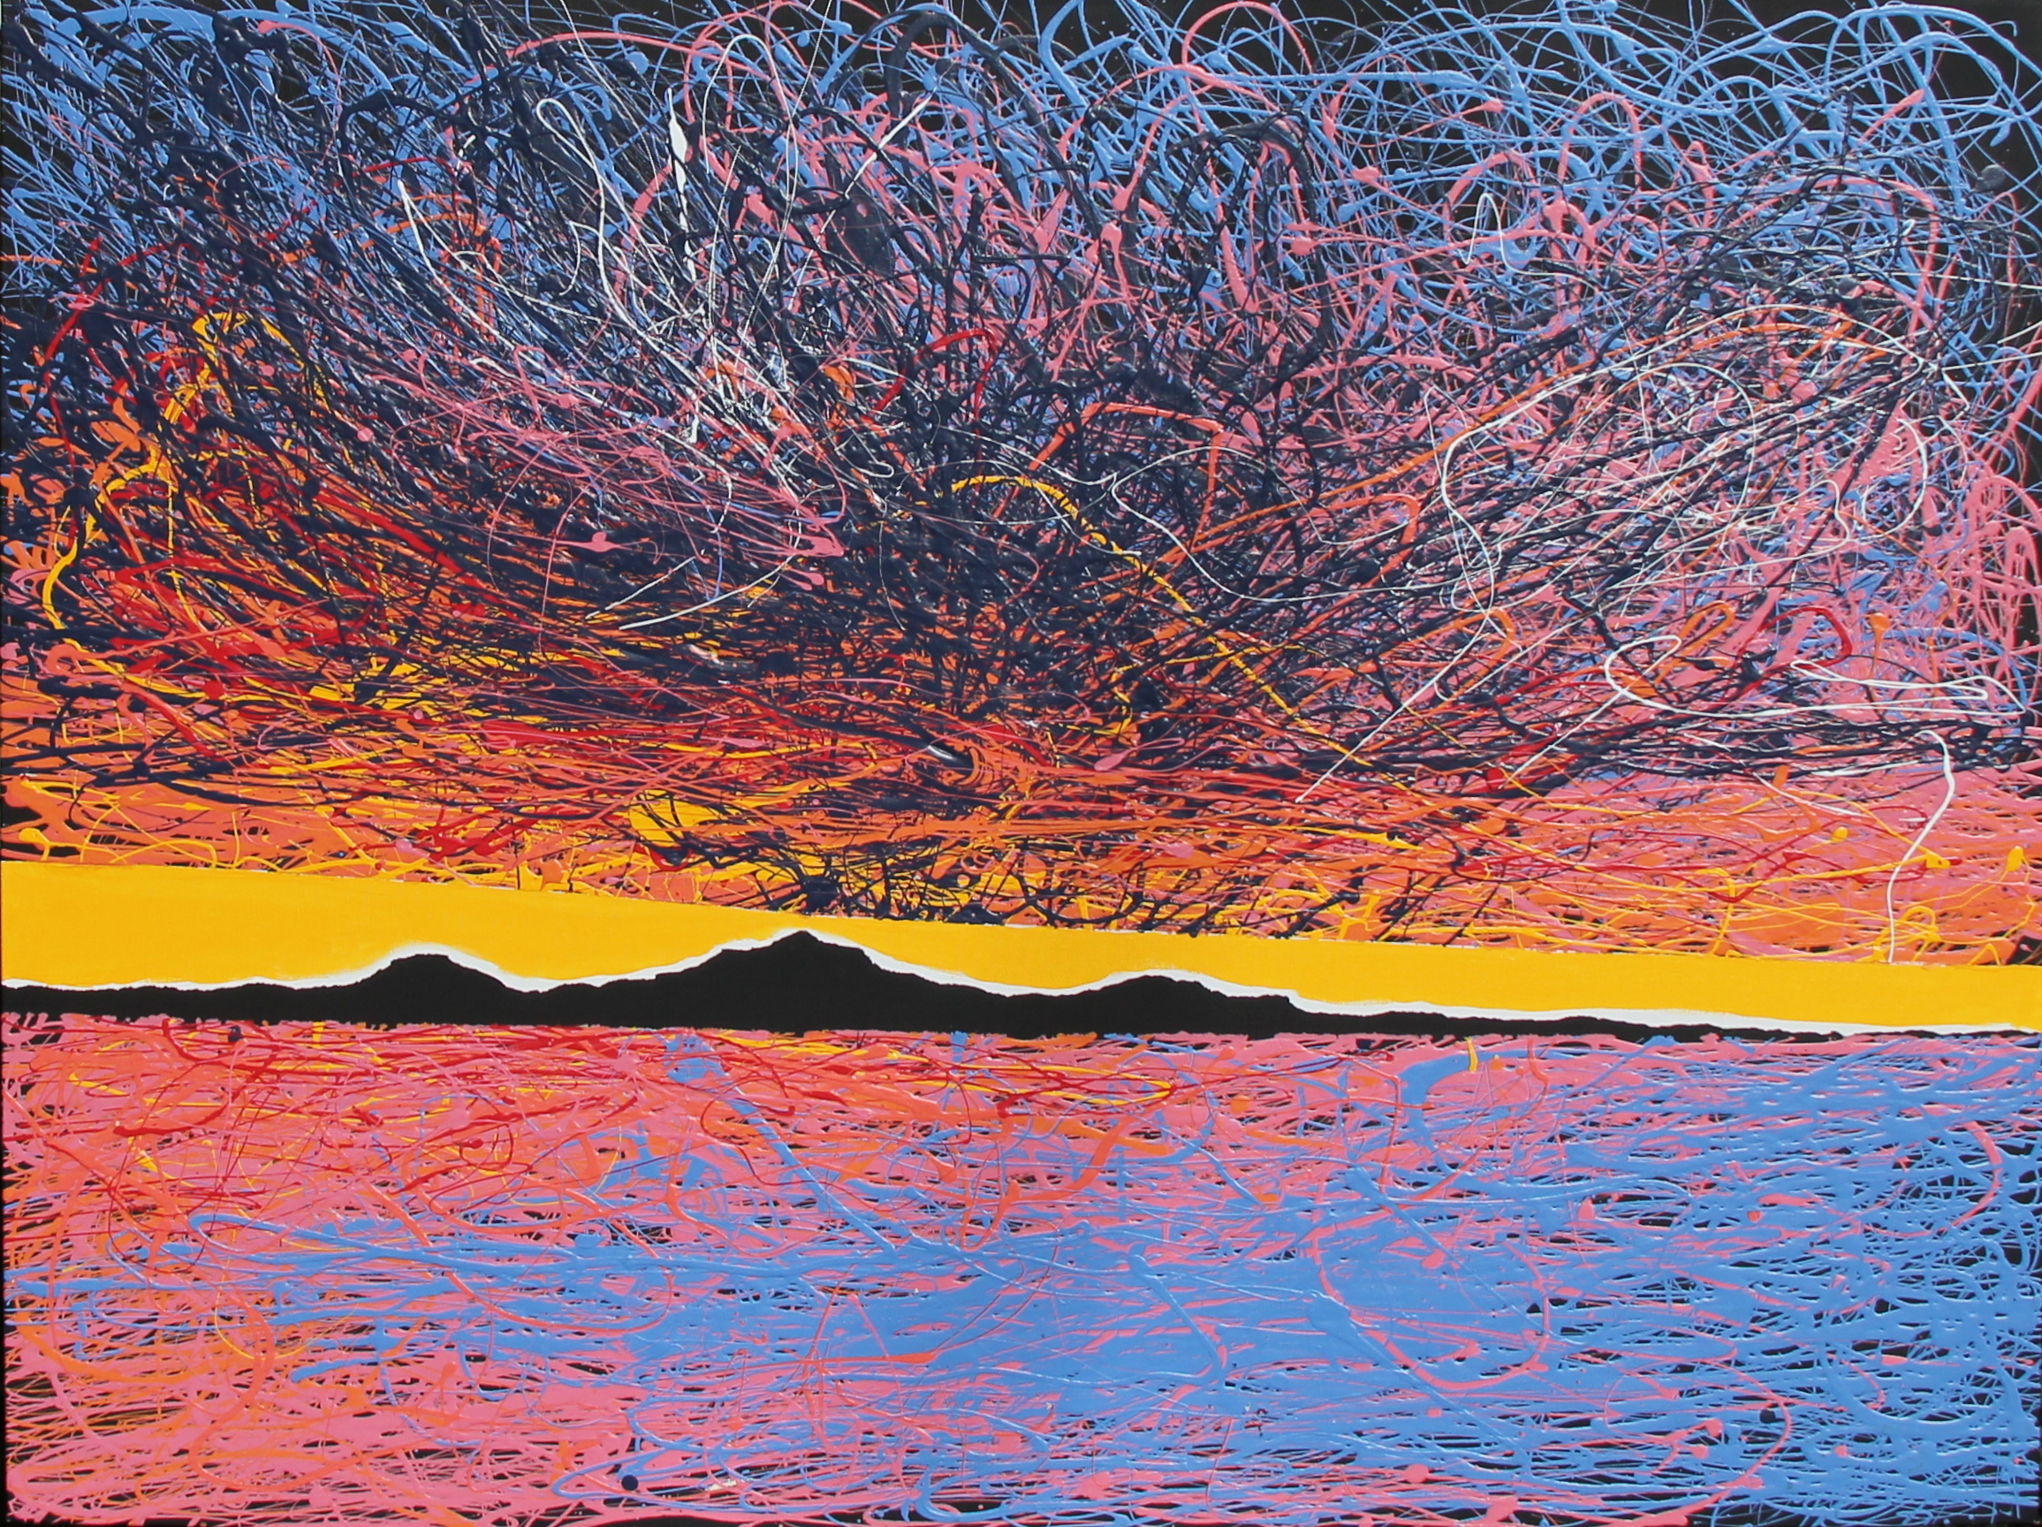

“Gulf Islands”, 36x48”, acrylic and latex on canvas, 2012.

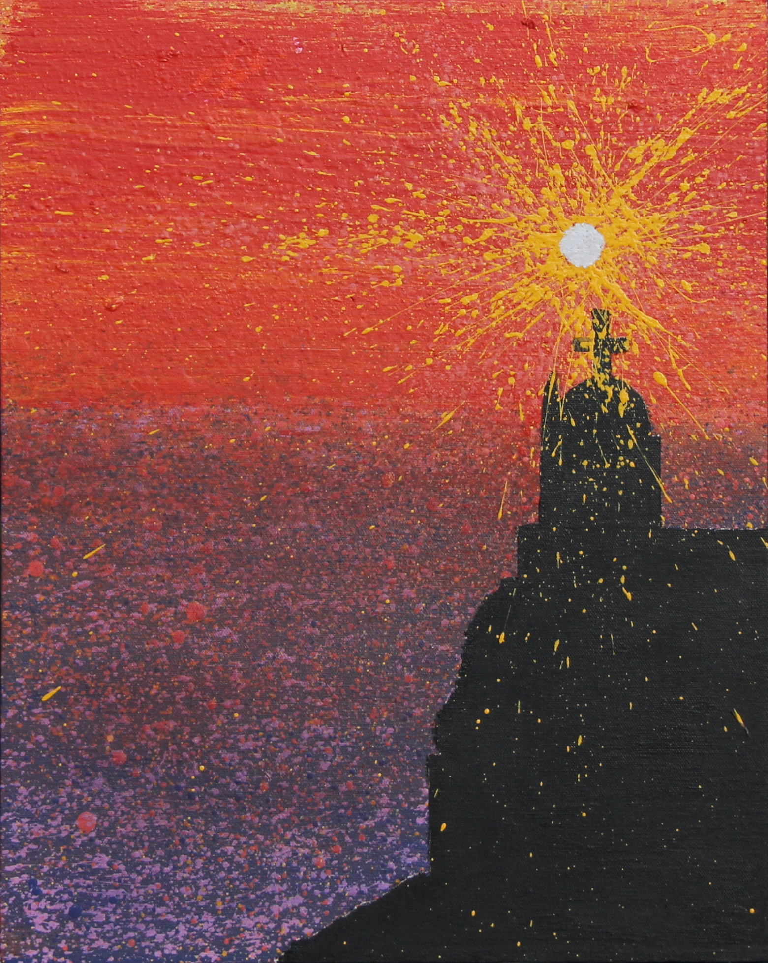

“Santorini Sunset”, 18x24”, acrylic and latex on canvas, 2012.

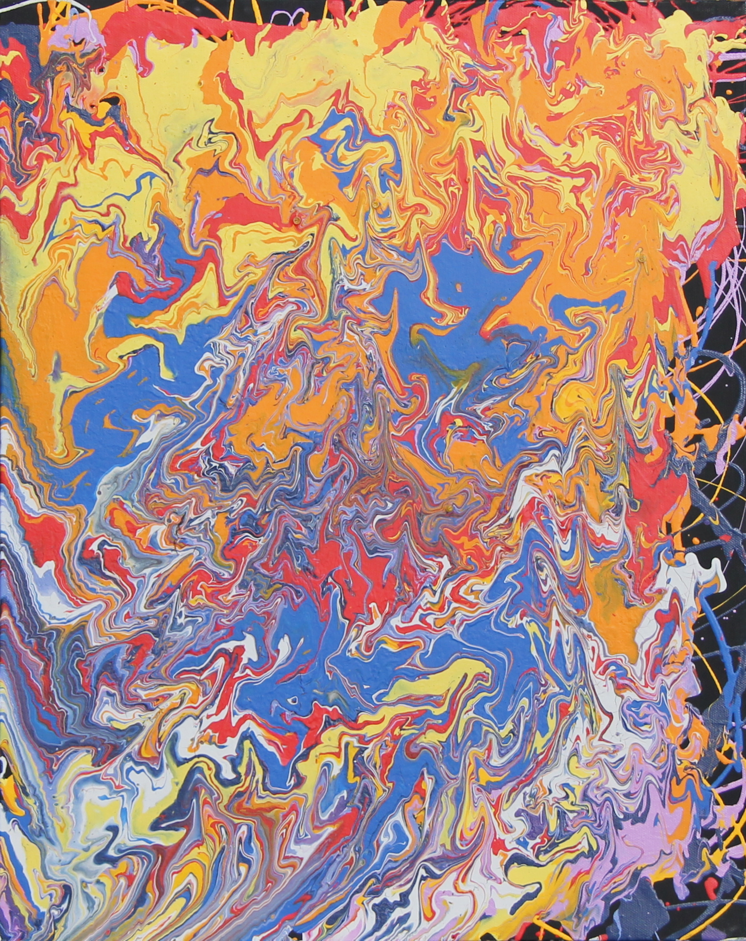

“Monastery”, 18x24”, latex on canvas, 2013.

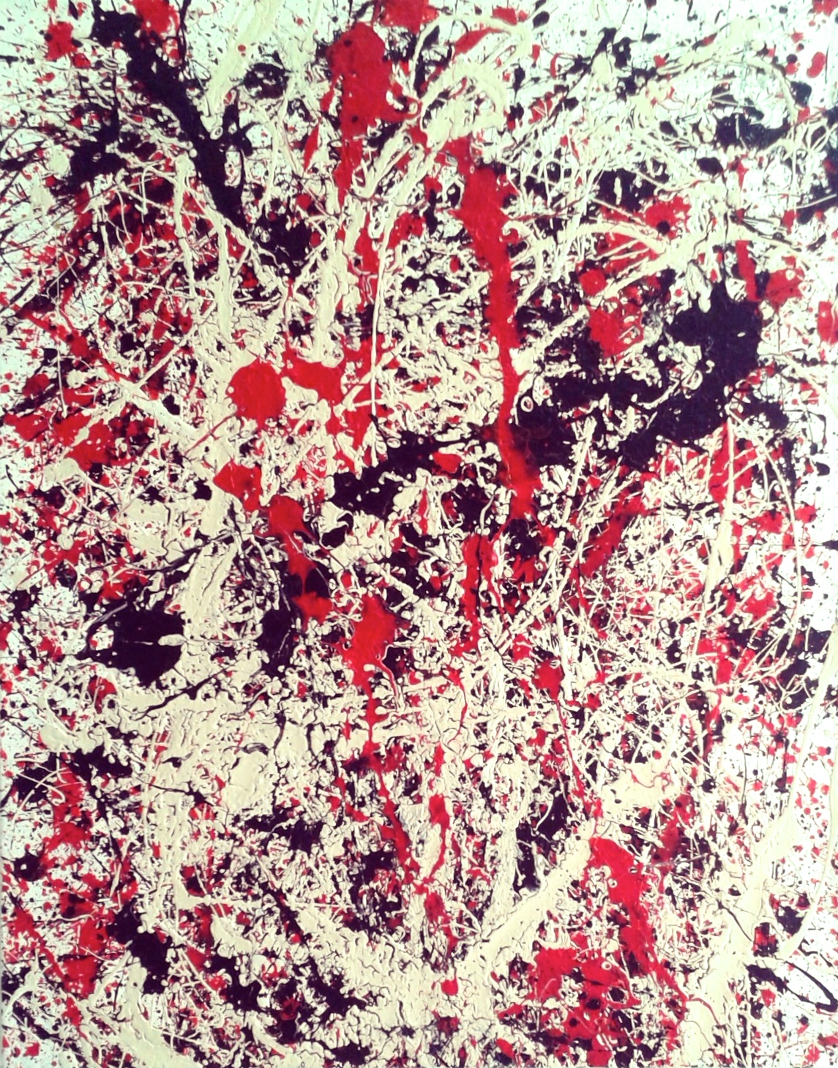

“Genesis Part. 2”, 20x28”, acrylic and latex on canvas, 2012.

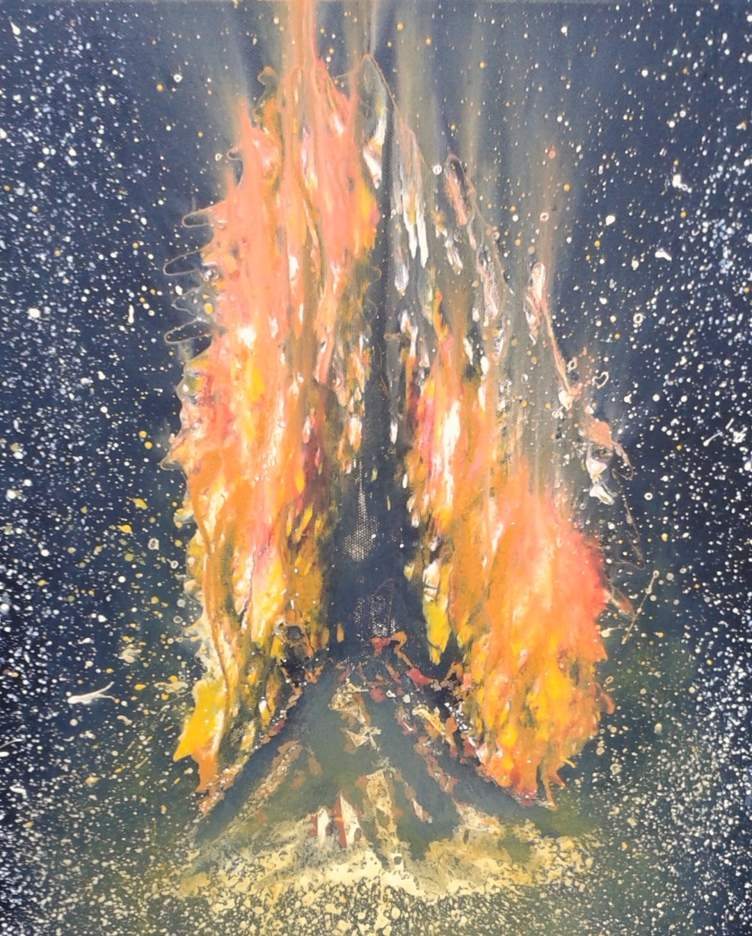

“Wildfire”, 18x24”, acrylic and latex on canvas, 2013.

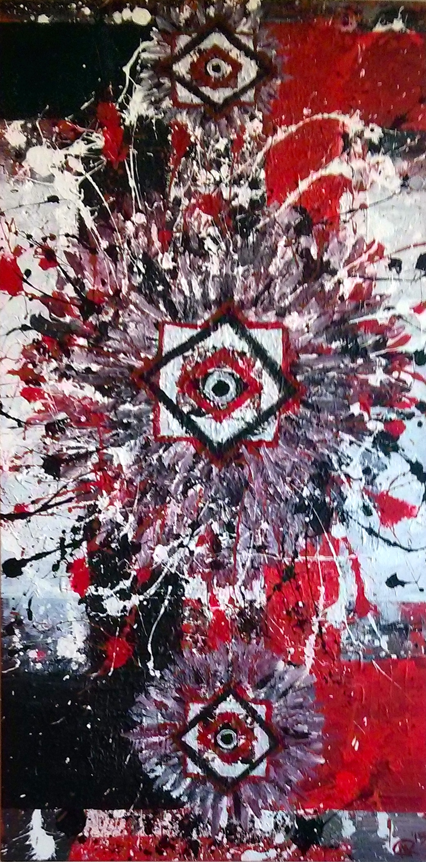  
“Untitled”, 24x48”, acrylic and latex on canvas, 2014.

∆, 48x60”, acrylic, latex, and pastel on canvas, 2015.

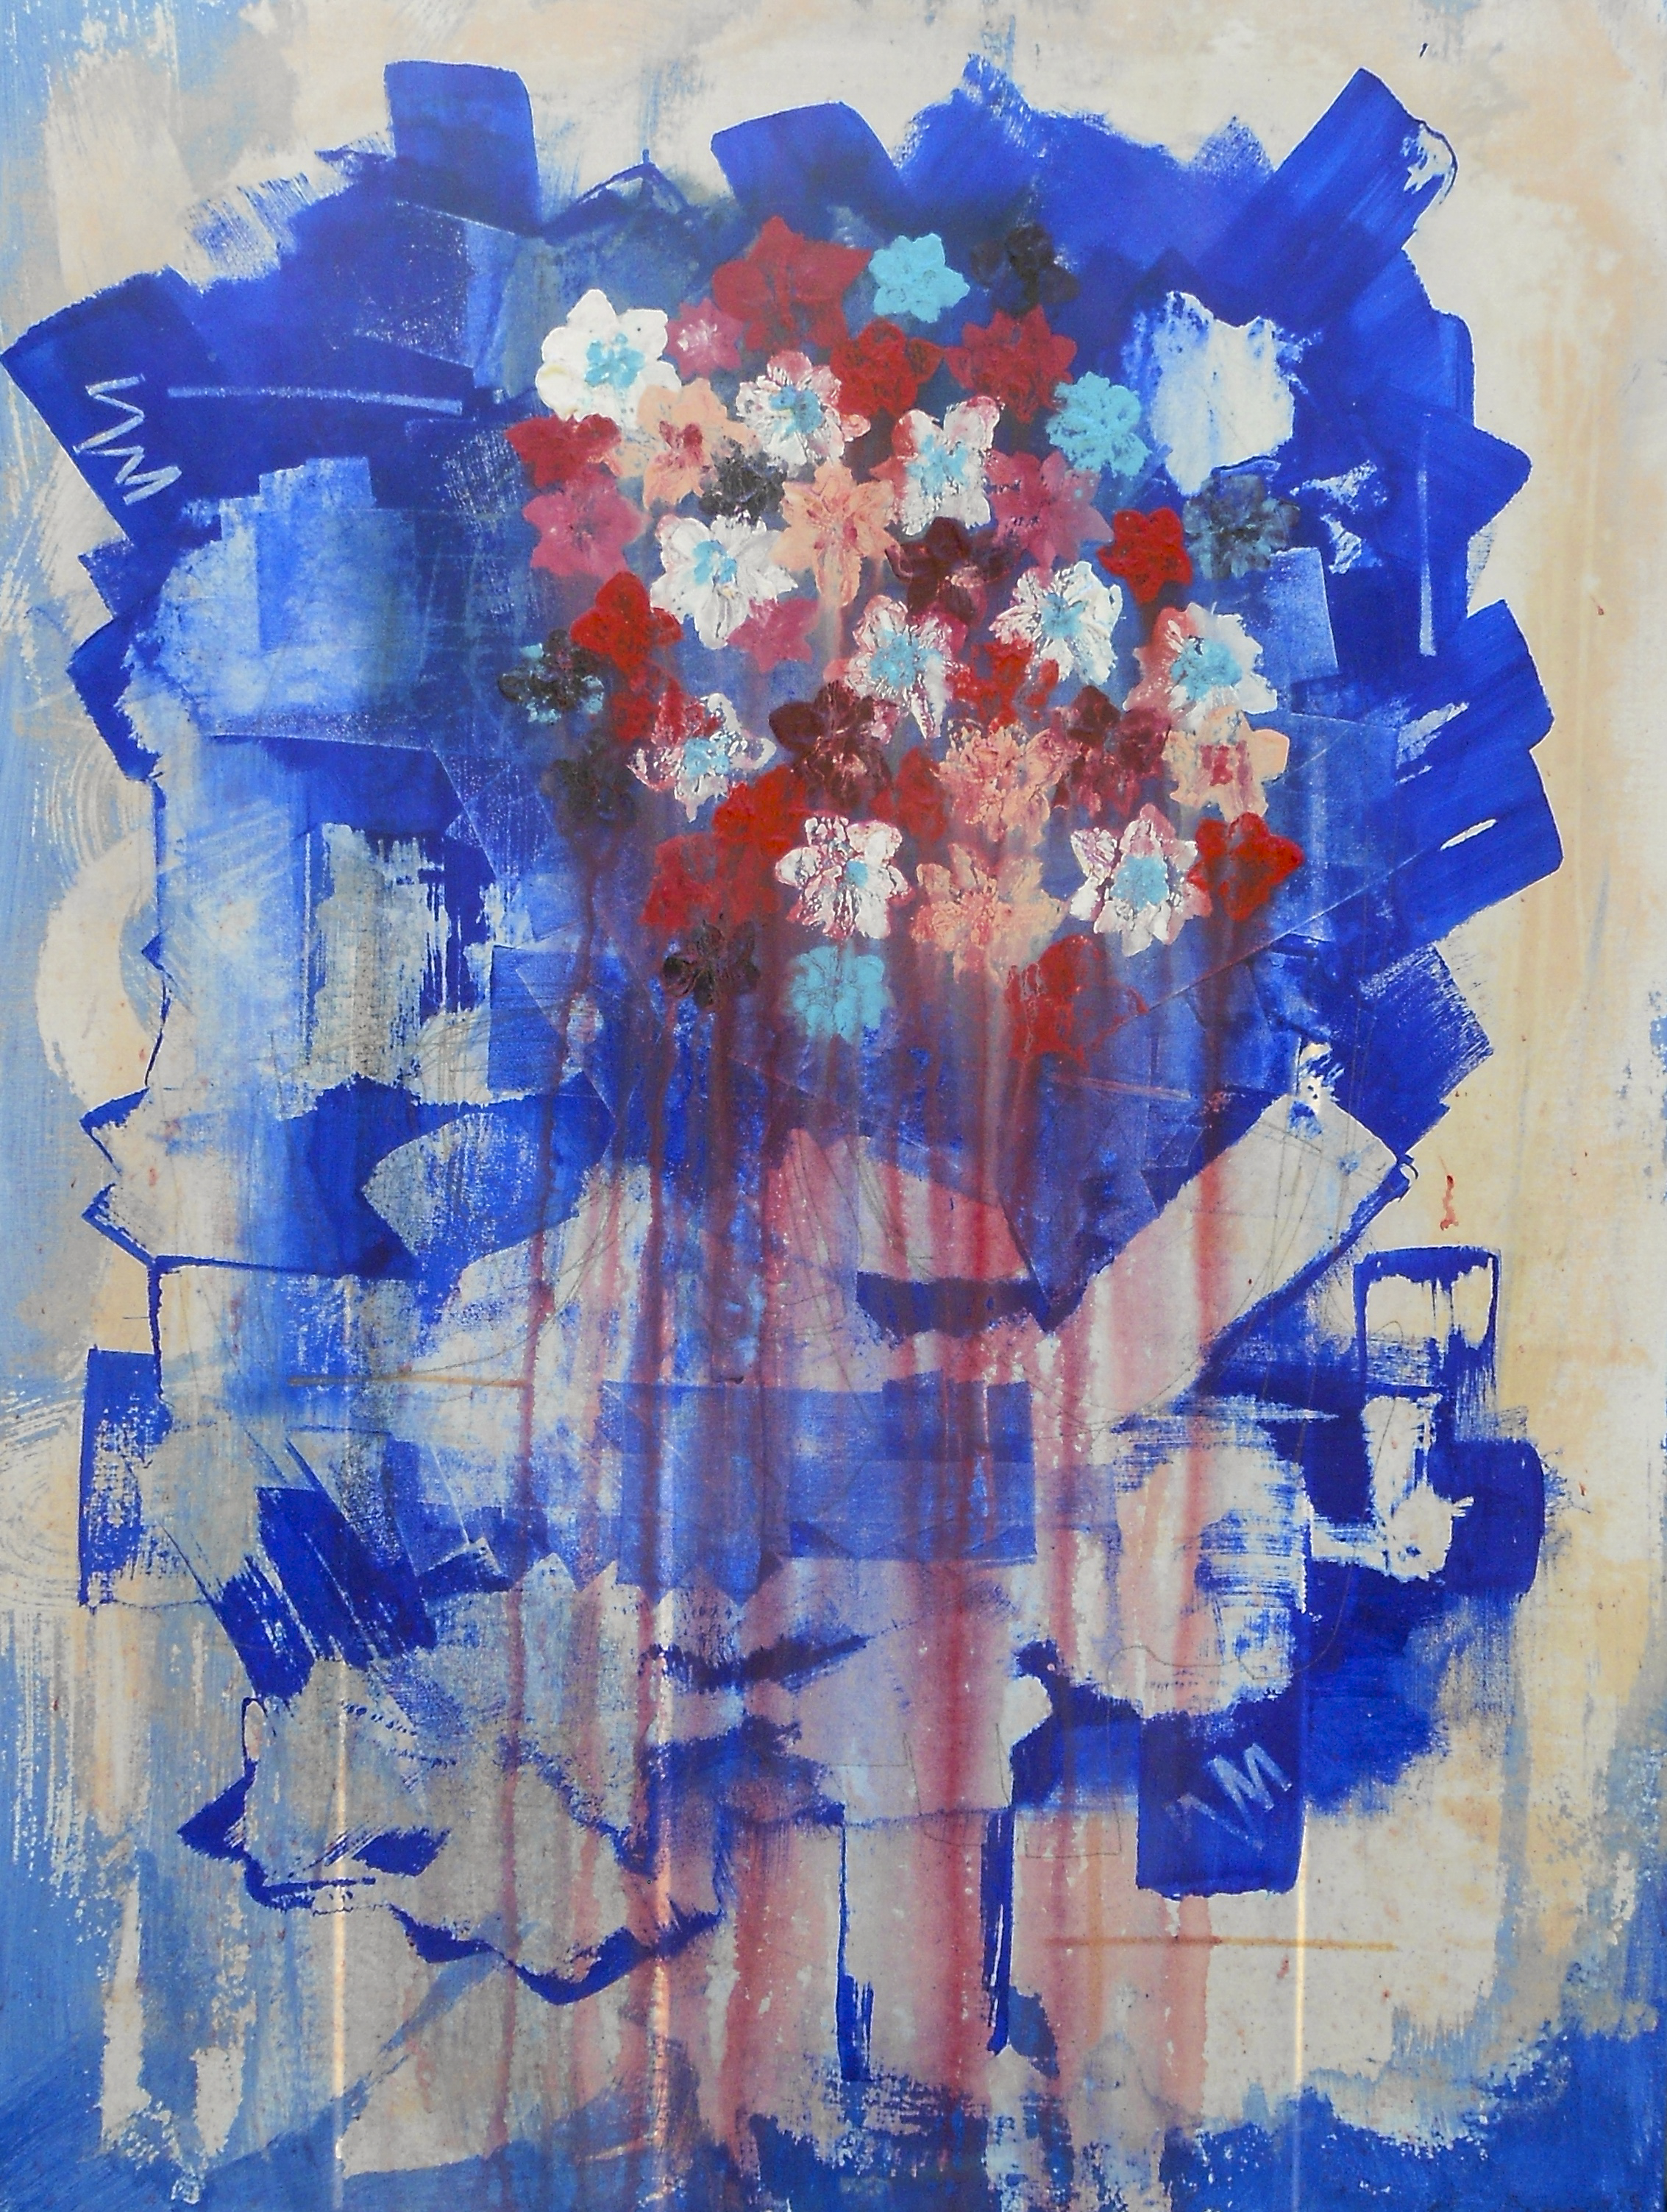

“Bleed”, 30x40”, acrylic and latex on canvas, 2015

🡪 (New Page) Header = Projects:

1. **“Connections” – mural project in collaboration with Scott Sueme, as part of HCMA’s Artists in Residence Program, May 2015**

**Statement:**

Working with ‘Connections’ as a key concept, the design features a colourful set of interlocking and connecting shapes. The geometry is designed to lead the eye from one object to the next, illustrating their connection to each other and as a whole. With that as a focus, the shapes attribute this quality without a linear pattern, or repetition of a specific shape – they are meant to feel organic with a hand painted quality.

The brightly coloured design walks the line between graffiti and modern art, featuring two areas of interest with texture cropped within large shapes. One representing a street and city space, using weathering and graffiti painting techniques, the other represents a green space, or space for nature, featuring full foliage and leaves captured from trees around the Vancouver area. The idea is to illustrate these two colour spaces in contract with each other, but also balanced and connected as part of a bigger picture. This piece pays a tribute to the landscape of Vancouver and our connection with nature as city dwellers.

1. **“Foundations” - in collaboration with Scott Sueme, sponsored by HCMA, Tilt World Curiosity Labs, and Royal Bay Secondary School, August 2015.**

Statement:

Our approach to the project was to highlight our backgrounds in abstract painting to create a piece that is representational while keeping a bold youthful energy. The design was inspired by the architecture of the building, complimenting its linear forms, while creating contrast with organic pattern making. The image is made up of four structural tiers, one built on top of the other to create a whole. Each tier is its own unique pattern and colour narrative. The lowest level portrays the colours found in Emily Carr’s painting “Above the Gravel Pit”, and the rich natural surroundings to the school. The second depicts the school’s strong modern colours as a foundation on top of the existing landscape. Third, the school’s raven and home colours are represented in a more uniform pattern. Finally, the top tier is a return to a natural influence resembling the Pacific Northwest sky. The four tiers combine elements of the location’s past, present, and future into a singular design, also functioning as a visual anchor within the school. Given its unique location with multiple perspectives points, the work invokes a visual response based on the vantage point from where it is viewed. The project overall ties together an artistic approach to colour, design, and functionality to embody the community of Royal Bay Secondary School.

**🡪(New page) Header = About:**

Michael Rozen is a Canadian artist born in Vancouver. Coming from a graffiti background he now works predominately in various paint mediums on canvas and board. His work reflects experimentation in abstraction, expressionism, and impressionism. Currently he lives and studies political science in Montreal at McGill University. Alongside his studies Michael continues to work on expanding his process and developing new avenues of expression. His latest works have played with the line between representing and abstracting reality.

🡪 (New page) Header = Contact:

(include one artwork to the right of info)

For inquiries please contact me by email at the address provided below. Thank you for your visit.

* Email: [m.rozen.art@gmail.com](mailto:m.rozen.art@gmail.com) (Hyperlink)
* Instgram: @m.rozen (hyperlink to page)